Mashpee Wampanoag Tribe
483 Great Neck Rd. South,
Mashpee, MA 02649
Phone (508) 477-0208 Fax (508) 477-1218
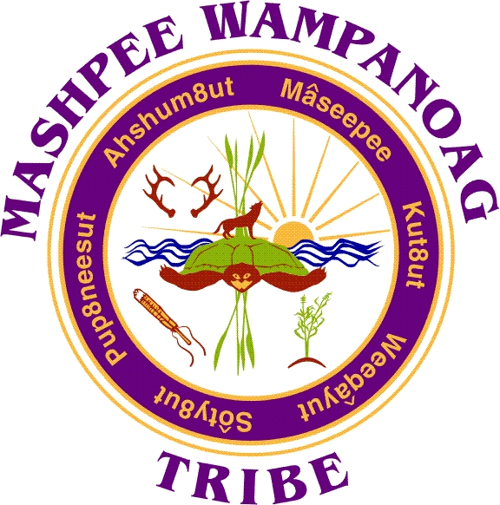

Job Title: Archivist
Department: Tribal Historic Preservation
Reports To: Department Director/THPO
Status: Part Time (Non-Exempt)
Hours: 32 hours per week
Salary: $38.50 per hour
Closing Date: February 28th, 2023 / Until Filled

Summary: The Mashpee Wampanoag Tribe (MWT) and Tribal Historic Preservation Department (THPD) are looking for a professional archivist to continue the development and operation of the Tribal archives program. The Archivist will work closely with THPD director, tribal leaders, historians and archival colleagues locally and regionally to expand upon long term and strategic planning of Tribal collections management. Additionally, the Archivist will be charged with expanding the Inventory Assessment, the upkeep of accession records and finding aids, as well as digitizing current holdings.

The Archivist will have additional support from the THPD director, Tribal members, interns and undergraduate student workers. The primary deliverable of the project is to continue the digitization of the onsite collections, implementation of internal policies and procedure controls, integrate localized accessibility and in adherence to appropriate care plan of the materials.

In addition to basic archival processing, the Archivist is charged with raising public awareness of the collection, including, but not limited to, working with Tribal leadership, membership, local historic societies and archives towards creating physical and online exhibitions that align with broader THPD goals and initiatives.

Essential Duties and Responsibilities: Includes the following, while other duties and responsibilities may be assigned.
- The Mashpee Wampanoag Tribal Archives (MWTA) office shall have the responsibility of locating and preserving documentation pertaining to Mashpee and Wampanoag Tribal material culture, traditions, history, governance and lifeways;
- Administer the MWTA office and conduct research, collect information, and implement the Department’s policies concerning preservation of Wampanoag cultural materials;
- Present a dedicated safe and secure space for historic records and items of cultural provenance to be preserved for future generations and stewarded by the collective Tribal body in perpetuity
- Serves as a vital resource and essential component to cultural transmission
- Further set up the authoritative institution for Mashpee Wampanoag historical research relating to literature, scholarly works, manuscripts, records, other unique and rare items.
- Compile accurate records of activities and expenditures for grant and quarterly reports
- Apply best practices for data management and digital preservation for all deposited content
- Develop meaningful relationships with other off-site repositories in the Commonwealth, in New England, and beyond in order to acquire access to primary source collections relating to Mashpee Wampanoag history, culture, and language
- Cultivate a “Community of Practice” & an Ethic of collecting within the Tribal community revolving around the concepts, strategies, techniques, and critical thinking involved in Archival Science
- Define Records Management functions to address “Records Retention and Disposition Scheduling” implement standards, policies, procedures involved in the management of all Tribal records

Key Competencies: To perform the job successfully, an individual should demonstrate the following competencies:
- Follows instructions, responds to management direction, and adheres to policies and procedures
- Demonstrates accuracy and thoroughness, with a high level of attention to details
- Maintain professionalism at all times being polite and courteous to fellow staff, visitors and peers
- Ability to work independently and demonstrate proficient productivity standards
- Exhibits professional sound and accurate judgment
- Dependable and consistently at work and on time
- Completes tasks on time or notifies appropriate person with an alternate plan
- Identifies and resolves problems in a timely manner
Education and Experience: Minimum qualifications: Bachelor's degree from an ALA-accredited library or information science program with a concentration in archival studies required; minimum of two years' experience working in an archives or library preferred; processing experience preferred; experience with multi-format collections, including audiovisual and photographic materials preferred. Familiar with and or capable of learning to develop and maintain applicable archival database management software. Able to proficiently use Microsoft Office suite programs such as Word, Excel, Outlook, and PowerPoint (minimally) independently.

Qualifications: To perform this job successfully, an individual must be able to perform each essential duty satisfactorily. The requirements listed below are representative of the knowledge, skill, and/or ability required. Reasonable accommodations may be made to enable individuals with disabilities to perform the essential functions.

Language Ability: Ability to read and comprehend simple instructions, short correspondence, and memos; and demonstrates ability to write professional or collegiate level correspondence.

Math Ability: Ability to add, subtract, multiply, and divide in all units of measure, using whole numbers, common fractions, and decimals.

Reasoning Ability: Ability to apply common sense understanding to carry out detailed but uninvolved written or oral instructions. Ability to deal with problems involving a few concrete variables in standardized situations.

Certificates and Licenses: Must possess a valid driver's license.

Work Environment: The work environment characteristics described here are representative of those an employee encounters while performing the essential functions of this job. Reasonable accommodations may be made to enable individuals with disabilities to perform the essential functions.

Physical Demands: The physical demands described here are representative of those that must be met by an employee to successfully perform the essential functions of this job. Reasonable accommodations may be made to enable individuals with disabilities to perform the essential functions.

Specific vision abilities required by this job include distance vision, depth perception and ability to adjust focus. While performing the duties of this job, the employee is regularly required to stand; walk; sit; use hands to finger, handle, or feel and reach with hands and arms. The employee is required to talk or hear.

Additional Requirements: Able to work in the archival climate controlled environment; which is kept below 70º in compliance with Archival standard specifications.

Preference is given to qualified Native American candidates in accordance with the Indian Preference Act of 1934 (Title 25, U.S.C., Section 472)

