Mashpee Wampanoag Tribe
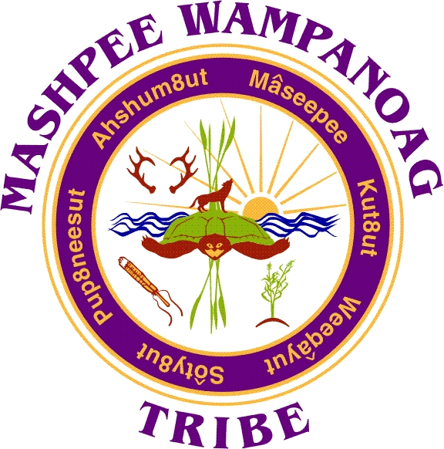
483 Great Neck Rd So. Mashpee, MA 02649
Phone (508) 477-0208 Fax (508) 477-1218

Job Title: Tribal Administrator
Location: Mashpee Wampanoag Tribe (MWT) – Business Offices
Reports To: Tribal Council Chairman
Department: Tribal Administration
Status: Full-time, Exempt
Salary: $80,000 - $110,000
Deadline to Apply: Open until filled

Summary: The Tribal Administrator (TA) is responsible for the oversight of all day-to-day Tribal services, and programs. The TA’s primary responsibilities shall include but are not limited to: planning, organizing, directing and administering a comprehensive management strategy for MWT Operations. This full-time management position works in concert with the Comptroller and Human Resources Director to ensure the efficient and effective delivery of services to Tribal citizens.

Essential Duties and Responsibilities include the following. Other duties may be assigned
- Direct, through department heads and managers, the work of Tribal Operations.
- Administer contracts and grants, subject to Tribal Council approval.
- Prepare and present to the Tribal Council a balanced budget to support Tribal Operations.
- Maintain a safe working environment for the Tribe, its employees and Tribal members.
- Maintain a Tribal administration management strategy that sets measureable levels of service.
- In concert with the MWT HR Director, recruit, hire, transfer, promote, terminate and otherwise manage Tribal Operations employees in accordance with the MWT Employee Handbook, 2013-RES-033, and all applicable Tribal, and Federal laws.
- Apply, without exception, the applicable Indirect Cost Rate.
- Present quarterly reports regarding Tribal Operations to Tribal Council
- Manage and uphold the public relationships of the Tribe's name and image in the best possible manner.
- Insure that Tribal Members are updated via all approved means a summary of the activities and initiatives of Tribal Operations.
- Carry out other required Tribal administration duties as outlined by 2013-RES-033, Tribal, and Federal law and as assigned.

COMPETENCIES:
To perform the job successfully, an individual should demonstrate the following competencies:
- Possess experience in strategic planning and execution and have the ability or experience in grants management, budgeting, contracting, negotiating and governmental management.
- Knowledge of Tribal, Federal, and State employment, wage, and salary laws and regulation or have a willingness to become knowledgeable.
- Knowledge of the Tribe's 2012-ORD-001, Tribal Employment Rights Ordinance (TERO).
- Ability to analyze and assess training and development needs. Knowledge or organizational development theory and practices.
- Experience in design, development and implementation of salary administration plans and benefit programs.
- Experience in examining and reengineering operations and procedures, formulating policy, and developing and implementing new strategies and procedures.
- Professional written and verbal communication and interpersonal skills.
- Understanding of Tribal sovereignty as it relates to Federal, State, and local laws and regulations, especially in labor laws and other matters of employment with a Tribal government operation.
- Shows respect and sensitivity to Native Americans and Native American culture.

Qualifications:
To perform this job successfully, an individual must be able to perform each essential duty satisfactorily. The requirements listed below are representative of the knowledge, skill, and/or ability required.
Education/Experience:
Bachelor’s degree in Public Administration, Business Administration or related field required along with a minimum of 5 years’ experience in executive management, public administration, financial management or related field preferably related to federally recognized Tribes.
Tribal Community Knowledge of Needs:
Preference given to an applicant who can demonstrate extensive knowledge of the Mashpee Wampanoag community’s needs, programs, and services to the stakeholder population.
Other Requirements:
Must be able to pass a National criminal history background check. Must pass a drug screen.
Language Ability:
Ability to read and interpret documents such as safety rules, operating and maintenance instructions, and procedure manuals. Ability to write routine reports and correspondence. Ability to speak effectively before groups of customers or employees of organization.
Math Ability:
Ability to calculate figures and amounts such as discounts, interest, commissions, proportions, percentages, area, circumference, and volume. Ability to apply concepts of basic algebra and geometry
Reasoning Ability:
Ability to solve practical problems and deal with a variety of concrete variables in situations where only limited standardization exists. Ability to interpret a variety of instructions furnished in written, oral, diagram, or schedule form.
Computer Skills:
To perform this job successfully, an individual must be proficient in the use of Microsoft Office (Word, Excel, PowerPoint, Access, and Outlook) and Financial systems.
Certificates and Licenses:
Must possess a valid driver’s license.
Supervisory Responsibilities:
Carries out supervisory responsibilities in accordance with the organization’s policies and applicable laws. Responsibilities include planning, assigning, and directing work and addressing complaints and resolving problems.
Work Environment:
The work environment characteristics described here are representative of those an employee encounters while performing the essential functions of this job. Reasonable accommodations may be made to enable individuals with disabilities to perform the essential functions.
The noise level in the work environment is usually quiet.
Physical Demands:
Reasonable accommodations may be made to enable individuals with disabilities to perform the essential functions.
Preference is given to qualified Native American candidates in accordance with the Indian Preference Act of 1934 (Title 25, U.S.C., Section 472)

Apply to:

Marita Scott, Interim HR Director
Mashpee Wampanoag Tribe
483 Great Neck Road South
Mashpee, MA 02649
or
marita.scott@mwtribe-nsn.gov

