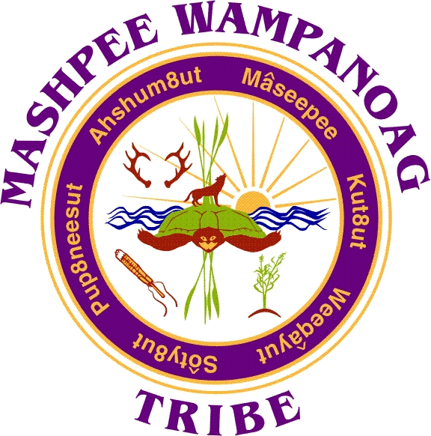
Mashpee Wampanoag Tribe
483 Great Neck Rd So. Mashpee, MA 02649
Phone (508) 477-0208 Fax (508) 477-1218

Job Title: Assistant Director
Location: Mashpee Wampanoag Tribe Community and Government Center
Reports To: Education Department Director
Department: Education
Status: Full-time, Exempt
Salary Range: $63,000 - $70,000 Annual
Deadline to Apply: Open until filled

SUMMARY:
The Assistant Education Director of Education serves as primary support to the Education Director within the scope of the tribe’s Education Department. The Assistant Director is responsible for working directly with Program Managers and Coordinators; providing oversight and completing reporting; and supporting program planning and implementation.

ESSENTIAL DUTIES AND RESPONSIBILITIES:
- General office tasks/administrative duties: in the absence of the Director, the Assistant Director will be responsible for supervising staff, scheduling, database input, budget oversight and records maintenance as well as, office management.
- Works closely with Program Managers and Coordinators to successfully implement programs, attend required meetings, and complete reporting
- Administers program grants and activities, including contracts, budgets, procurement, reporting, and other requirements in compliance with tribal and federal rules and regulations
- Provides oversight to website content and application
- Organizes opportunities on website and social media, ensuring information reaches tribal community in a variety of platforms.
- Serves as education committee liaison in development and implementation of education programs and activities on behalf of the department and tribe
- Provides guidance and direction to students at the elementary, secondary and post-secondary levels
- Provides guidance and support to parents/guardians at educational TEAM meetings for special education services at all grade levels
- Maintains effective communication with parents, caretakers, community members, teachers, and school support personnel on the overall development and wellbeing of tribal children
- Represents tribal educational interests at school committee and other professional meetings, colleges, presentations, conferences, events, trainings
- Provides advocacy and research support in curriculum development and planning
- Assists with program evaluation, assessment and grant reporting
- Assists with search for funding opportunities; assists with grant submissions
- Communicates effectively and openly with parents and the public; continue positive School/community relationships and partnerships.
- Works collaboratively with diverse groups to solve common challenges.

EDUCATION/EXPERIENCE QUALIFICATIONS:
Experience with implementation of federal and other grant programs and budgets; familiarity with educational and developmental needs of tribal youth and young adults; understanding of post-secondary institutions, admissions/financial aid process, and ability to network and build coalitions. Experience collaborating with external agencies, and successfully organizing high-level meetings. Ability to facilitate discussions and lead meetings. Demonstrated success working with teams of Native and non-Native professionals.

PREFERRED QUALIFICATIONS:
Master’s Degree in education or a related field; Extensive budget and project management experience. Familiarity with tribes, LEAs, and the State education agencies. Special Education experience; GED experience; experience working with tribal youth and tribal communities.

COMPETENCIES:
- Must possess a valid driver’s license and MUST pass CORI/background check.
- Proficient in Microsoft Office (Word, Access, Excel, Publisher) and Outlook
- Solution-oriented, team-player; experience with data-informed decision-making
- Research experience, and understanding of quality continuous improvement;
- Experience working with research-based and evidence-based
- Strong interest in working with post-secondary institutions and future Native teachers
Additional Requirements:
Must submit to and pass a comprehensive background check and drug screening.
Preference is given to qualified Native American candidates in accordance with the Indian Preference Act of 1934 (Title 25, U.S.C., Section 472)

Apply to:
Human Resources
Mashpee Wampanoag Tribe
483 Great Neck Road South
Mashpee, MA 02649
marita.scott@mwtribe-nsn.gov

