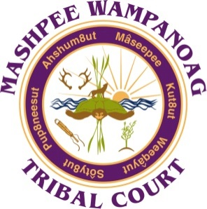

MASHPEE WAMPANOAG TRIBAL COURT
MASHPEE WAMPANOAG TRIBE
)
)
) ADMINISTRATIVE ORDER #30
) Policy on District Court Orders Relating to
) ICWA or the Child & Family Ordinance

This Administrative Order is designed to create a consistent format when a District Court Judge renders an Order or Judgment specifically with respect to matters heard under the Tribe’s Child and Family Ordinance or under the Indian Child Welfare Act 25USC, §1911, et seq. Recently the Tribal Council appointed a Second District Court Judge on a per diem basis. It is imperative that any District Court Judge be able to pick up a file and continue presiding over and monitoring a file without a hitch or delay. Particularly with respect to cases where the Indian Child Welfare Act is implicated or the case falls under the Tribe’s Child and Family Ordinance, it is essential to have next events regularly scheduled until the case is concluded by virtue of a Final Order or Judgment.
Therefore, it is hereby made an order that all cases under the foregoing statute or ordinance be continued for status at least every ninety (90) days. As part of each hearing, the order must reference a showing by the THHSD (Tribal Health and Human Services Department), of what “Active Efforts” have been made to reunify the family, and the results of those active efforts.

Effective upon adoption of this Order, all open cases will be scheduled for a status/update hearing ninety (90) days from the last docketed Order or, if it has been more than ninety (90) days, the earliest possible date, in accordance with this Administrative Order. Notice to all parties shall include the purpose for the hearing (i.e.: “The Court hereby requires THHS Department to provide an Active Efforts Status Report on month/day/year.”).
IT IS SO ORDERED this 1st day of November, 2018.
BY THE COURT:

__________________________________
Robert F. Mills, Acting Chief Judge
Mashpee Wampanoag Supreme Court

