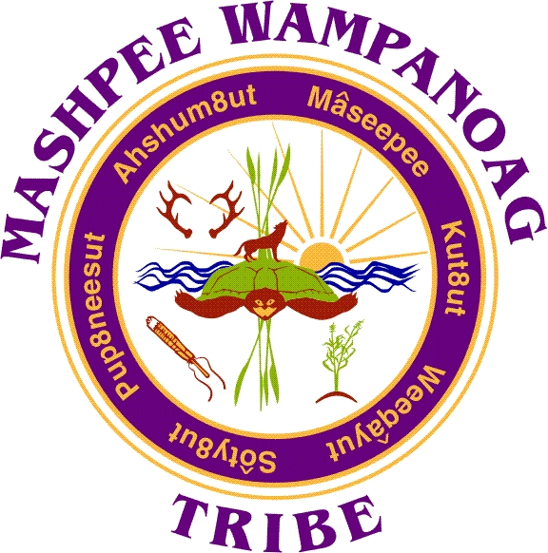
Mashpee Wampanoag Tribe
483 Great Neck Rd So. Mashpee, MA 02649
Phone (508) 477-0208 Fax (508) 477-1218

Job Title: Case Manager
Location: Men’s Healing Lodge
Reports To: Vice-Chairman
Status: Part-time; up to 20 hours
Salary Range: $35.00 per hour (contingent upon continued funding)

SUMMARY: The Men’s Healing Lodge Case Manager plays a crucial role in assisting individuals recovering from substance abuse by providing support to the House Manager to facilitate positive outcomes. The Case Manager collaborates with residents, treatment professionals, and external agencies to create a compassionate and accountable living environment.

ESSENTIAL DUTIES AND RESPONSIBILITIES:
- Conducts intakes by interviewing potential residents, and completing assessments. Ensures supporting documentation is received.
- Provides recovery housing support services to residents including treatment planning, group counseling, discharge planning and other related duties as assigned.
- Refers residents to resources in the community including but not limited to housing, education, detoxification services and mental health therapeutic services.
- Assists with and provides input for developing and/or updating sober house manuals, policies and procedures.
- Organizes, schedules and evaluates sober house living environment.
- Administers and documents various types of toxicology screens as needed
- Ensures the sober house meets all applicable laws, codes and policy standards. Documenting and reporting necessary updates/repairs to Vice-Chairman and assisting with coordination of maintenance/repairs.
- Conducts random inspections of resident rooms and the sober house. Reports/documents finding for Vice-Chairman and House Manager.
- Completes incident reports when appropriate and forwards them to the Vice-Chairman and House Manager.
- Collaborates with outside recovery groups to provide weekly groups within the sober house.
- Manages revenue and expenditures and provides spreadsheets to the Vice-Chairman weekly.

REQUIRED QUALIFICATIONS
EDUCATION/EXPERIENCE:
At least 5 years managing a sober house, Associates Degree in applicable field or combination of experience and education

COMPETENCIES:
- 5+ years in sustained recovery from substance use disorder
- Knowledge of community resources
- Basic computer and keyboarding skills
- Valid driver’s license
- Ability to conduct a group appropriate for recovery support

Additional Requirements:
Must submit to and pass a comprehensive background check and drug screening.

Preference is given to qualified Native American candidates in accordance with the Indian Preference Act of 1934 (Title 25, U.S.C., Section 472)

Apply to:

Human Resources
Mashpee Wampanoag Tribe
483 Great Neck Road South
Mashpee, MA 02649
marita.scott@mwtribe-nsn.gov

