Mashpee Wampanoag Tribe
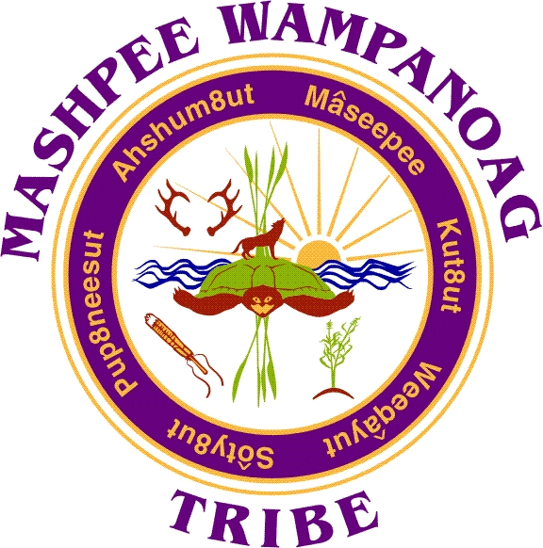
483 Great Neck Rd So. Mashpee, MA 02649
Phone (508) 477-0208 Fax (508) 477-1218

Job Title: NRD Field Assistant
Location: Mashpee Wampanoag Tribe (MWT) – Business Offices
Reports To: Natural Resources Director
Department: Natural Resources
Status: Full-time, Non-Exempt
Salary: $21.31 - $23.00/per hour
Deadline to Apply: Open until filled

Summary: The NRD Field assistant’s purpose is to support the MWT Natural Resources Department with the protection of the natural resources that have ensured the survival and well-being of the Mashpee Wampanoag since time immemorial and to sustain these resources for future generations. Our local natural resources include but are not limited to our waters (marine, estuaries, rivers, ponds, groundwater etc.), geology-soils, and terrestrial-aquatic-marine flora and fauna.

Essential Duties and Responsibilities include the following. Other duties may be assigned
- Become familiar with current NRD grant initiatives, and projects.
- Develop a thorough knowledge of MWT Natural Resources Department rules, regulations, and policies.
- Ability to adapt to a flexible work schedule, including: early morning work hours as dictated by local tides, and after general work hours as work activities/department projects may necessitate.
- Able to work independently and in combination with other department employees or agencies.
- Maintains regularly updated inventory of department supplies and equipment.
- Ensure regular upkeep and cleanliness of department vehicles, boats, supplies and equipment. Reports any damage or inadequacies as required.
- Prepare and submit weekly written reports, records or other documents as required.
- Effectively communicate orally and in writing to co-workers, superiors, the general public, other Tribal departments, governmental agencies, etc. as necessary.
- In a limited capacity, able to serve as a MWT NRD point of contact with municipal, state, federal and university partners when called upon.
- Patrol Tribal Trust lands and Mashpee National Wildlife Refuge Lands and assist with the removal of illegally dumped items.
- Trailer small to medium sized boating vessels and launch said vessels with confidence.
- Collect water quality samples and analyze, and process water quality monitoring data for various purposes and via various scientific methods.
- Work in collaboration with the Town of Mashpee Department of Natural Resources and other partner agencies as necessary.
- Maintains all water quality monitoring equipment, including but not limited to calibration of units and repairs.
- Occasional attendance of MWT Natural Resource Commission meetings as well as Town of Mashpee Shellfish Commission meetings at the request of the Director of Natural Resources or designee.
- Participate in developing volunteer programs and strategies to promote community engagement.
- Assist in the organization of volunteers to conduct water quality, fisheries, shellfish, and habitat enhancement projects.
- Takes part in and assists with the planning of conferences, trainings, workshops, and the MWT NRD POH Summer Camp.
- Must be willing to receive training in all aspects of Natural Resources and to travel and or stay overnight.
- Assist the MWT’s shellfish department when assigned.

Qualifications:
To perform this job successfully, an individual must be able to perform each essential duty satisfactorily. The requirements listed below are representative of the knowledge, skill, and/or ability required.
Education/Experience:
3 years’ experience in fish and wildlife conservation or similar field required, Bachelor’s Degree in environmental science or similar field preferred and may be substituted for 2 years’ experience
Other Requirements:
Must possess knowledge of basic grant and contracting processes for government agencies. Must be extremely organized and thrive in a fast paced environment.
Must be able to pass a criminal history background check. Must pass a drug screen.
Language Ability:
Ability to read and interpret documents such as safety rules, operating and maintenance instructions, and procedure manuals. Ability to write routine reports and correspondence. Ability to speak effectively before groups and/or individuals.
Math Ability:
Ability to calculate figures and amounts such as discounts, interest, commissions, proportions, percentages, area, circumference, and volume. Ability to apply concepts of basic algebra and geometry.
Reasoning Ability:
Ability to solve practical problems and deal with a variety of concrete variables in situations where only limited standardization exists. Ability to interpret a variety of instructions furnished in written, oral, diagram, or schedule form.
Computer Skills:
To perform this job successfully, an individual must be proficient in the use of Microsoft Office (Word, Excel, PowerPoint, Access, and Outlook) and financial systems.
Certificates and Licenses:
Must possess a valid driver’s license.
Work Environment:
The work environment characteristics described here are representative of those an employee encounters while performing the essential functions of this job. Reasonable accommodations may be made to enable individuals with disabilities to perform the essential functions.
The noise level in the work environment is usually quiet.
Physical Demands:
Reasonable accommodations may be made to enable individuals with disabilities to perform the essential functions.
Preference is given to qualified Native American candidates in accordance with the Indian Preference Act of 1934 (Title 25, U.S.C., Section 472)

Apply to:
Human Resources
Mashpee Wampanoag Tribe
483 Great Neck Road South
Mashpee, MA 02649
marita.scott@mwtribe-nsn.gov

