Mashpee Wampanoag Tribe
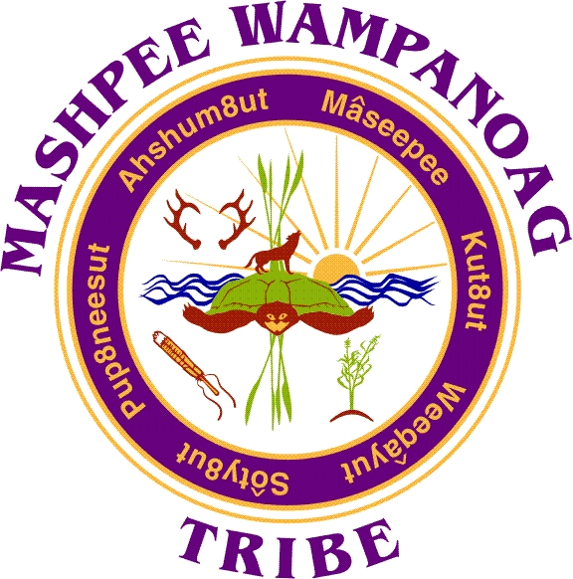

483 Great Neck Rd. South, Mashpee, MA 02649

Phone (508) 477-0208 Fax (508) 477-1218

Job Title: Farm Worker

Location: Mashpee Farm

Sampson Mills Road, Mashpee, MA

Reports To: Director of Title VI
Department: Title VI
Status: Non-Exempt - 20 hours a week
Salary Range: $21.00/hr.
Closing Date: Open until filled

SUMMARY:The Farm Worker will develop and manage all aspects of the Farm production fields including growing organic vegetables, fruits and herbs; identifying and selling in local markets and on-site; managing farm interns and working with volunteers; and speaking to public groups that frequent the farm for educational days. This position requires a physically endurance and strength, practical knowledge of agricultural skills and farm management, and a passionate commitment to providing specific foods for improved public health. The worker has primary responsibility for the planning, coordination and implementation of all work and activities at Farm and will take directions from the Farm Manager. The farm is a laboratory in the field focused on growing foods with the strongest disease prevention properties, conducting research to support this, improving community health, teaching communities how to grow these foods and making them widely available so individuals can learn how to incorporate them into their daily lives.

ESSENTIAL DUTIES AND RESPONSIBILITIES include the following.
- Supervision of farm interns and volunteers (patiently and respectfully)
- Coordination with farm staff and its advisory team including monthly board reports
- Produce annual field plans
- Maintain farm standards of production to ensure the highest quality produce
- Maintain farm infrastructure and landscape with the help of interns and volunteers
- Cooperate with community partners
- Seed ordering and material acquisition;
- Insect and weed control, fertility monitoring and general field observation;
- Cultivation activities; Infrastructure planning, creation and maintenance; Irrigation planning and implementation; Soil building program including composting
- Plan weekly harvest schedule, harvest, market and deliver;
- Performs other related duties as assigned by Director

COMPETENCIES:
To perform the job successfully, an individual should demonstrate the following competencies:
- Demonstrated farm planning experience and working knowledge of farm infrastructure
- Experience in growing using organic/biodynamic principles
- Experience working with farm machinery
- Basic carpentry skills
- Interest in working with youth and youth programs
- Experience working in a team environment with proven leadership skill
- Gathers and analyzes information skillfully
- Coordinates projects; communicates changes and progress
- Maintains confidentiality
- Responds well to questions
- Writes clearly and informatively; edits work for spelling and grammar
- Works within approved budget
- Shows respect and sensitivity to Native Americans and Native American culture
- Treats people with respect; works with integrity and ethically
- Manages competing demands; able to deal with frequent change, delays, or unexpected events
- Is consistently at work and on time
- Follows instructions and responds to management direction
- Asks for and offers help when needed
- Exhibits sound and accurate judgment and problem-solving
- Uses time efficiently
- Ability to repeatedly lift 50 pounds

Education/Experience:
Associate’s degree or high school diploma with two year’s related experience
or equivalent combination of education and experience.

PREFERRED QUALIFICATIONS: Bachelor’s degree in environmental science and/or related field, analytical experience, grant reporting experience, and extensive budget experience.

Certificates and Licenses:
- Must possess a valid driver’s license
- Must possess or be able to obtain all licenses, training, and certifications

Additional Requirements

Must pass a CORI/background check

Preference is given to qualified Native American candidates in accordance with the Indian Preference Act of 1934 (Title 25, U.S.C., and Section 472)

Apply by sending application, resume, and cover letter to:
Kayla Gomes, Human Resources Manager
Mashpee Wampanoag Tribe
483 Great Neck Road South
Mashpee, MA 02649
Or
Kayla.Gomes@mwtribe-nsn.gov

