Mashpee Wampanoag Tribe
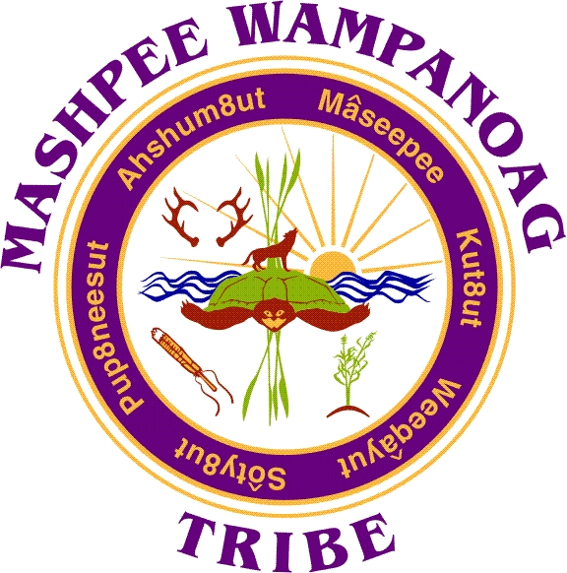
483 Great Neck Rd. P.O. Box 1048 Mashpee, MA 02649
Phone (508) 477-0208 Fax (508) 477-1218

Job Title: Cultural Resource Monitors

Department: Tribal Historic Preservation

Status: Full Time (Non-Exempt)

Hours: Mon-Fri (hours may vary)

Salary: $20.00 - $28.00 per hour

Closing Date: Until Filled

Summary: Cultural Resource Monitor (CRM0) will assist the department with processing Notice Of Intent (NOI) letters and by reviewing project materials to support departmental findings and determinations that inform comment letter replies; attend archaeological field school trainings and on reservation studies, complete cultural resource training, provide on-site field monitoring of projects as required, provide daily reports to THPO relative to project assignments. During off seasons additional responsibilities may be assigned as required to support department goals and initiatives.

Monitoring is for the protection of Wampanoag cultural resources during ground disturbing activities within ancestral territories of the Wampanoag Nation. These activities include archaeological observation over State and Federal construction project sites, archeological studies, cell tower/ utility and MassDOT infrastructure developments. CRM will be required to report all activities and findings to THPO and or senior department staff. .

Essential Duties and Responsibilities include the following but are not limited to; other duties may be assigned as deemed necessary. Ability to work independently with little to no supervision, reliable, punctual, attentive to details, culturally informed, familiar with general construction practices and exhibit discretion related to maintaining cultural sensitivity. Ability to read maps and utilize GIS (training can be provided). Training and occasional site supervision as it is made available or will be provided as needed.

Major Duties:
- For fill monitoring assignments reliably and be accountable for coordination through telephone dialogue, written & electronic correspondence
- Professionally communicate as THPD representative in coordination with assigned project Archeological, Natural Resources specialist and Construction supervisors or other points of contact
- Produce comprehensive detailed daily written reports of monitoring activities and associated mileage reporting related to project monitoring assignments, which includes responsible tracking of hours
- Assist in determining cultural sites ( potential areas identified as having cultural significance to the tribe)
- Immediate THPO notification of any impacted burial sites, notification includes appropriate agency, persons, and officials as well as immediately implementing stop work procedures (MG.L. unmarked burial laws)
- Take any and all necessary steps to learn and further develop a better understanding of Archaeology as a science, with the ability to incorporate cultural insight and understanding
- Use record keeping devices, such as cameras, GPS units, compasses, and measuring tapes effectively

Competencies:
To perform the job successfully, an individual should demonstrate the following competencies:
- Observes safety and security procedures; reports potentially unsafe conditions; uses equipment and materials properly.
- Shows respect and sensitivity to Wampanoag culture and traditional practices.
- Basic familiarity of Traditional pre-contact lifeways, a general knowledge of natural and cultural resources utilized by Wampanoag
- Physically able to walk to off-road sites up to a two miles when necessary and to stand for extended periods (all day)
- Able to endure and adjust to inclement weather conditions, frequent change, delays, or unexpected events related to working outdoors
- Attends and completes training and refresher classes on Cultural Resource Monitoring, Archaeology, GIS and other applicable field trainings as opportunities become available
- Attend and complete OSHA and HAZMAT (Hazardous material(s)) training course for certification

Additional Requirements:
Candidate must be willing and able to work based on the needs of the organization. Job may (though rarely) require occasional assignments on overnights and or weekends.

Qualifications:
To perform this job successfully, an individual must be able to perform each essential duty satisfactorily. The requirements listed below are representative of the knowledge, skill, and/or ability required. Reasonable accommodations may be made to enable individuals with disabilities to perform the essential functions.

Education/Experience Required:
- High school diploma or general education degree (GED) or; 3 years’ experience in related field.
- Knowledge of Wampanoag culture, traditions and territory
- Able to work out doors during spring, summer, fall and winter 8-10 hours a day
- Interpersonal communication, verbal and in writing
- Proficient in Microsoft office suite of products and basic general computer operating skills (Microsoft word, excel, power point and outlook minimally) are mandatory
- Basic navigation, use of a compass and GPS (global position system) and ability to utilize GIS (global information system) programs (training can be provided)
- Must maintain a valid license and have their own reliable transportation (mandatory)

Language Ability:
- Ability to read and comprehend simple instructions, draft short correspondence, and memos
- Ability to write simple correspondence emails
- Ability to effectively present information and articulate concerns in one-on-one and small group situations to customers and clients related to project assignments

Math Ability:
- Ability to add and subtract two digit numbers and to multiply and divide with 10's and 100's Ability to perform these operations using units of American money and weight measurement, volume, and distance.
- Ability to use metric measuring tape and devise

Reasoning Ability:
Ability to apply common sense understanding to carry out detailed in depth written or oral assessments and findings factoring in cultural and traditional insight. Ability to deal with problems involving a few concrete variables in standardized situations with understanding of archaeological studies and construction practices.

Certificates and Licenses:
Must possess a valid driver's license and registered vehicle

Work Environment:
The work environment characteristics described here are representative of those an employee encounters while performing the essential functions of this job. Reasonable accommodations may be made to enable individuals with disabilities to perform the essential functions.

While performing the duties of this job, the person is regularly exposed to outdoor weather conditions, which at times includes extreme weather and environmental conditions.
The noise level in the work environment is usually moderate however this job requires some construction site monitoring where heavy equipment is in use.

General safety and awareness of surroundings is a required skill while working in the field and on construction projects. Often times work will be in woodland settings where

Physical Demands:
The physical demands described here are representative of those that must be met by an employee to successfully perform the essential functions of this job. Reasonable accommodations may be made to enable individuals with disabilities to perform the essential functions.

The person must frequently lift and/or move up to 50 pounds. While performing the duties of this job, the employee is regularly required to stand for long durations and walk long distances to work sites.
The employee is frequently required to use hands to finger, handle, or feel; reach with hands and arms; climb or balance and stoop, kneel, crouch, or crawl

Preference is given to qualified Native American candidates in accordance with the Indian Preference Act of 1934 (Title 25, U.S.C., Section 472)

Please send all inquiries with Application, Resume, and Cover Letter to the Mashpee Wampanoag Tribes’ Human Resources Director and Cc THPO/THPD Director David Weeden; Hard Copies can be mailed to:
David Weeden
Tribal Historic Preservation Director
Mashpee Wampanoag Tribe
483 Great Neck Road South,
Mashpee, MA 02649
Email:
David.Weeden@mwtribe-nsn.gov

Kayla Gomes
Human Resources Director
Mashpee Wampanoag Tribe
483 Great Neck Road South,
Mashpee, MA 02649
Email:
Kayla.Gomes@mwtribe-nsn.gov

